**Multimedia Technology (CS 605C)**

**MCQ PREPARATION CLASSES**

1. RLE Stands for

Ans. Run Length Encoding

1. MIDI is an
2. Protocol B. Device C. LAN

Ans. Protocol

1. PAL is a/an
2. Digital video Standard
3. Analog Video Standard
4. Audio File standard
5. Image file standard

Ans. B. Analog Video Standard

4. Interlacing

a) provides a flicker-free Image without increasing bandwidth

b) provides a flicker-free Image by increasing bandwidth

c) adjust the color contrast

d) none of these,

Ans. a) provides a flicker-free Image without increasing bandwidth

5. SGMLstands for

a) Structured General Medium Language

b) Standard Generalized Markup Language

c) Standard Generalized Medium Language

d) None of these,

Ans. b) Standard Generalized Markup Language

6. Raster scanning starts from

a) top left corner of the screen

b) top right corner of the screen

c) bottom left corner of the screen

d) none of these,

Ans. a) top left corner of the screen

7. Pixelation means

a) individual pixel becomes visible

b) increasing image length

c) increasing bit depth

d) increasing image width.

Ans. a) individual pixel becomes visible

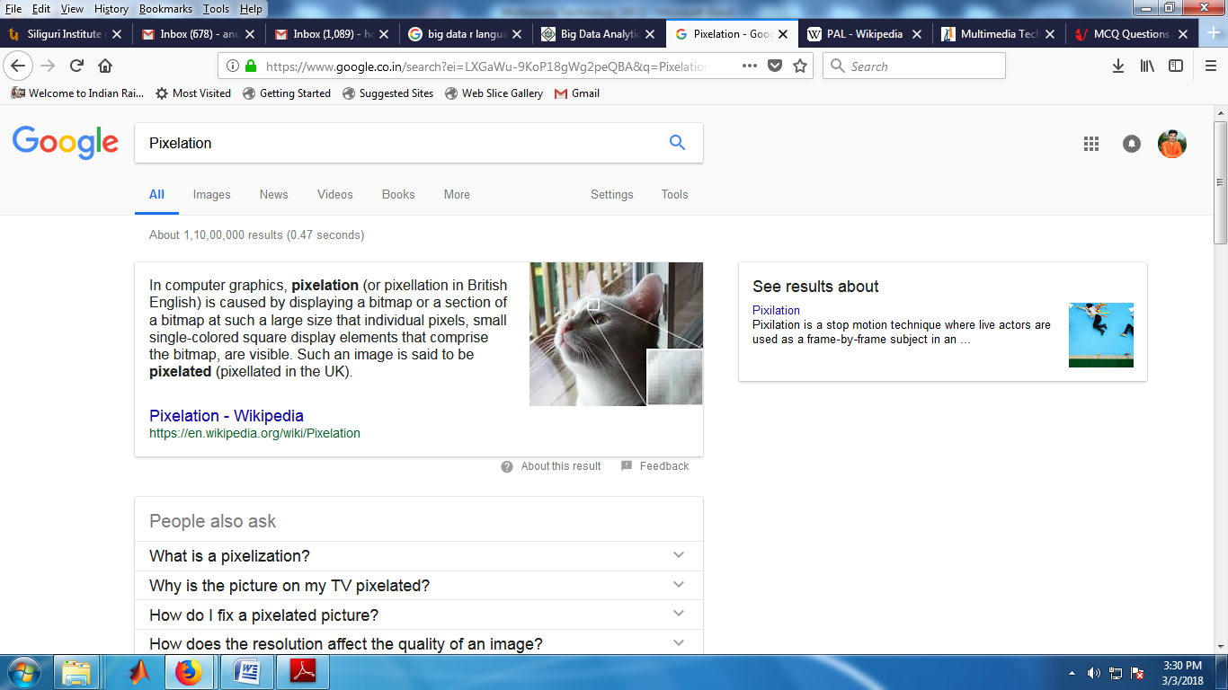

8. Huffman encoding is a/an

a) entropy encoding b) source encoding

c) hybrid encoding d) none of these.

Ans. a) entropy encoding

**Entropy coding** is a type of lossless **coding** to compress digital data by representing frequently occurring patterns with few bits and rarely occurring patterns with many bits. Huffman **coding** is a type of **entropy coding**.

9. Block size in block preparation step of JPEG compression is

a) 4 x 4 b) 8 x 8

c) 16 x 16 d) 64 x 64

Ans. b) 8X8

10. Purpose of DCT is to transform the block

a) from frequency domain to spatial domain

b) from spatial domain to frequency domain

c) both the frequency and spatial domain

d) none of these.

Ans. b) from spatial domain to frequency domain

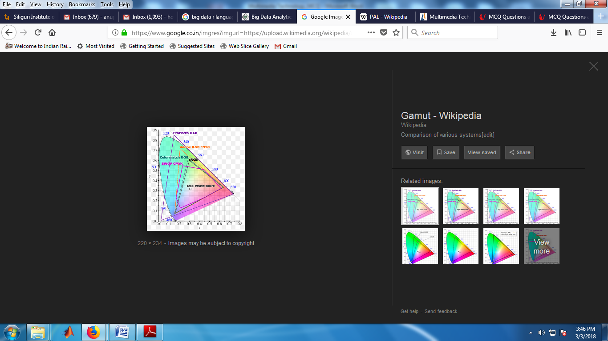11. Gamut in RGB is __________ CMYK.

a. equal to

b. smaller than

c. larger than

d. twice than that of

Ans. c. larger than

Definition of: **color gamut**. **color gamut**. The entire range of **colors** available on a particular device such as a monitor or printer. A monitor, which displays RGB signals, typically has a greater **color gamut** than a printer, which uses CMYK inks.

12. Opening is

a. Erosion then dilation

b. dilation then erosion

c. only erosion

Ans. a. Erosion then dilation

Graylevel **opening** consists simply of a graylevel **erosion** followed by a graylevel **dilation**. **Opening** is the dual of closing, i.e. **opening** the foreground pixels with a particular structuring element is equivalent to closing the background pixels with the same element.

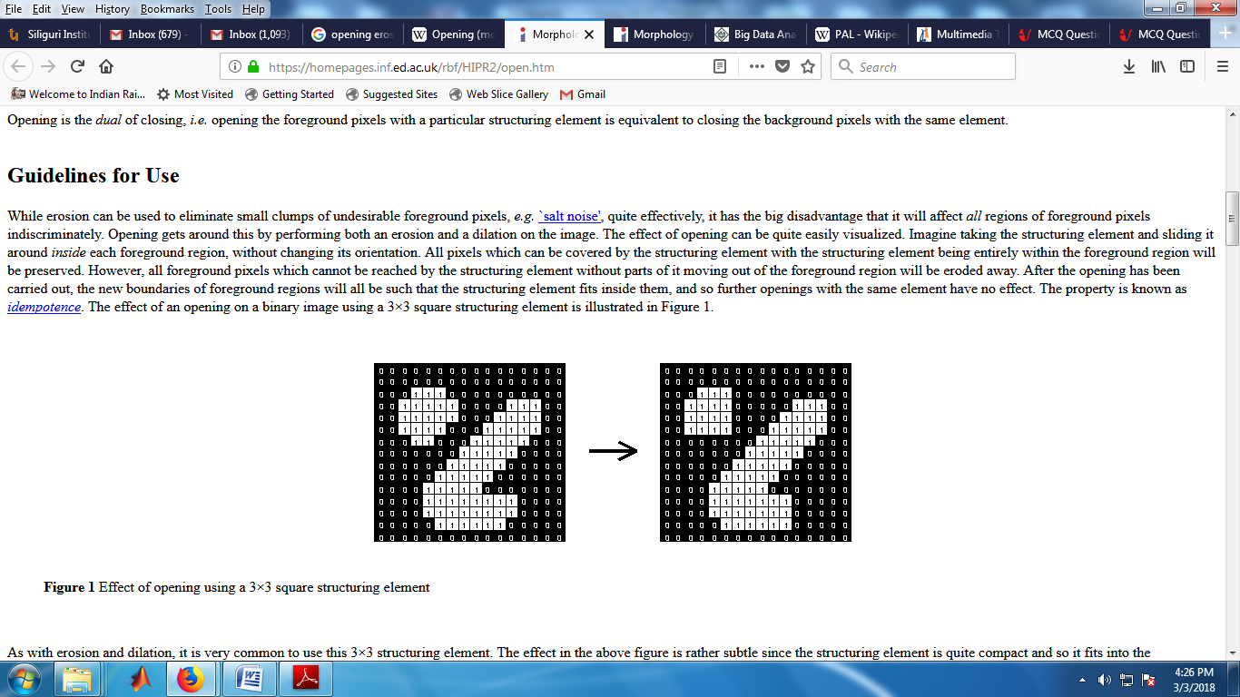

13. CD ROM operates on

a. 1 Mode b. 2 Modes c. 3 Modes d. 4 Modes

Ans. b. 2 Modes

Mode 1 is for storing computer data and Mode 2 is for compressed audio or video data.

14. H.261 contains how many layers

Ans. 4 layers

